AutoLead Intelligence Dashboard – Complete Plan (AID)
Build a centralized read-only performance dashboard where automotive dealers can see all ad platforms (Facebook, Google, TikTok, LinkedIn, Instagram, etc.) — leads delivered, spend, clicks, and ROI — in one place.

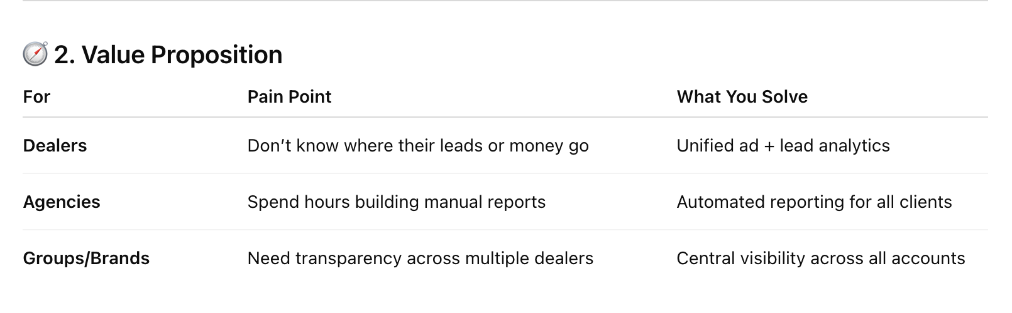

Key Features to be included in the first phase.
Key Features: Phase I
- Dealer login (multi-dealer support)
- API integrations:
  - Meta Ads (Facebook + Instagram)
  - Google Ads
  - TikTok Ads
  - LinkedIn Ads
- Metrics:
  - Leads filled
  - Ad spend
  - Impressions
  - Clicks
  - Cost-per-lead (CPL)
  - Platform/source breakdown
- Dashboard visualizations:
  - KPI cards (Leads, Spend, CPL)
  - Line charts (Leads & Spend over time)
  - Bar charts (Platform comparison)
  - Leads table (Lead source, date, ad name)
- Export as PDF or Email summary

Key Features Phase II

New Features:
- Google Analytics 4 integration
→ See traffic, conversions, top pages.
- Lead quality scoring
→ Based on platform, ad engagement, conversion type.
- Automated dealer reports
→ Weekly/monthly reports with highlights.
- ROI calculator
→ (Revenue from CRM ÷ Ad Spend) × 100
- Dealer comparison view (for agency-level usage)
- Multi-brand filtering (e.g., Toyota, Hyundai dealers)

Dashboards and Metrics to Include

A. Overview Section

Metric | Description
Total Leads | Leads from all connected platforms
Total Ad Spend | Combined spend across Meta, Google, etc.
Cost Per Lead (CPL) | Total Spend ÷ Total Leads
Clicks | Sum of all ad clicks
Impressions | Total ad views
CTR | Clicks ÷ Impressions
ROI | (Revenue ÷ Spend) × 100
Platform Breakdown | Leads, Spend, CPL by platform

B. Channel Performance View
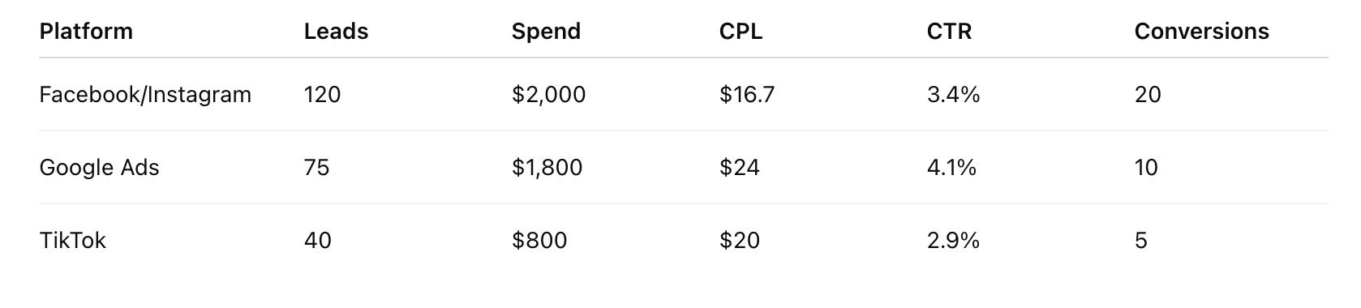
C. Leads Detail View I Add filters and sorting for platforms)
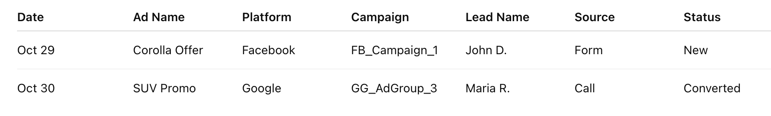

D. ROI Insights
- Leads vs Spend chart (trend line)
- Conversion funnel (Impressions → Clicks → Leads → Sales)
- ROI % by platform

E. Dealer Reports
- Auto-generated PDF / email summary
- Top-performing campaigns
- CPL trend
- Spend summary
- Quality insights (“Most leads came from TikTok video ads”)

6. Example Use Case Flow
- Dealer logs in to your dashboard.
- Connects Facebook, Google, TikTok, LinkedIn (OAuth).
- System fetches:
  - Ad Spend
  - Clicks, Impressions
  - Leads (form fills)
- Dashboard shows:
  - “You spent $4,600 and got 240 leads this month.”
  - “CPL: $19.17”
  - “Facebook leads 60%, Google 30%, TikTok 10%.”
- Dealer can filter by date, platform, or campaign.
- Weekly report sent automatically.

Input for Claude :
AutoLead Intelligence Dashboard (AID)
Product Requirements – v1.0

1. Product Overview
AID is a centralized, read-only performance dashboard for automotive dealers (and their agencies) to see all ad and organic performance in one place:
- Paid channels: Meta (Facebook + Instagram), Google Ads, TikTok Ads, LinkedIn Ads
- Organic & web: Google Analytics 4

- Optional CRM revenue input for ROI
Primary goals:
- Give dealers a single source of truth for leads, spend, CPL, and ROI.
- Support multi-dealer, multi-brand usage for marketing agencies.
- Automate weekly/monthly reporting with simple, actionable insights.

2. Scope & Phasing

Phase I – Core Ads Performance
In scope:
- Dealer login & multi-dealer support
- OAuth connections to:
  - Meta Ads (FB + IG)
  - Google Ads
  - TikTok Ads
  - LinkedIn Ads

  - Google analytics
- Data model & ingestion jobs (read-only)
- Core metrics:
  - Leads (form fills / conversions)
  - Ad spend
  - Impressions
  - Clicks
  - Calculated: CPL, CTR
- Dashboards:
  - Overview
  - Channel Performance
  - Leads Detail
  - Basic ROI insights (using spend & leads, but not yet CRM revenue)
- Visualization:
  - KPI cards
  - Line charts over time
  - Bar charts by platform
  - Leads table
- Export as:
  - PDF
  - Email summary (manual or scheduled basic)

Intelligence & Comparisons
Add:
- GA4 integration
  - Traffic, conversions, top pages, source/medium.
- Lead Quality Scoring
  - Score per lead (e.g., 0–100 or 1–5 stars) using:
    - Platform
    - Ad engagement metrics (clicks, time on site if GA4 present)
    - Conversion type (e.g., form, call, chat)
  - Dealer-level configuration for scoring weights (optional advanced setting).
- Automated Reports
  - Weekly & monthly email/PDF, auto-generated.
  - Include:
    - Summary metrics
    - Top campaigns
    - CPL trend
    - Spend breakdown
    - Quality insights.
- ROI Calculator
  - Formula: ROI % = (Revenue from CRM ÷ Ad Spend) × 100
  - Support:
    - Manual revenue input per period
    - OR CSV/CRM import (even if basic at first).
- Dealer Comparison View (Agency)
  - For agency users who manage multiple dealer accounts.
  - Side-by-side or aggregated stats.
- Multi-Brand Filtering
  - Example: agency filters by “Toyota” vs “Hyundai” dealers.
  - Brand metadata at dealer profile level.

3. User Types & Permissions

3.1 User Roles
- Dealer User
  - Can see only their own dealer data.
  - Typical roles:
    - Owner / GM
    - Marketing manager
  - Permissions:
    - View dashboards, reports
    - Export PDF
    - Configure integrations (OAuth for that dealer only)
    - Manage filters & date ranges.
- Agency User
  - Can see multiple dealers.
  - Permissions:
    - Everything dealer can do, across assigned dealers.
    - Access “Dealer Comparison” & multi-brand view (Phase II).
- Platform Admin (internal)
  - Internal AID staff.
  - Manage all dealers, troubleshoot integrations.
  - View logs, integration errors, sync status.

3.2 Authentication & Authorization
- Login:
  - Email + password
  - Optional SSO (Google / Microsoft) – nice-to-have.
- Security:
  - Enforce strong passwords.
  - JWT or similar token-based auth.
  - Role-based access control (RBAC).
- Multi-dealer mapping:
  - Each user linked to one or more Dealer entities.
  - Agency users linked to multiple Dealers.
  - Permissions must prevent data leakage across dealers.

4. Integrations – Functional Requirements

4.1 Meta Ads (Facebook + Instagram)
- Connection via OAuth.
- Store:
  - Ad account IDs
  - Page IDs (if needed for lead forms).
- Data to fetch (per account / per campaign / per ad set / per ad):
  - Date
  - Impressions
  - Clicks
  - Spend
  - Conversions / leads (standard lead form / custom conversion events)
- Sync:
  - Daily full sync (for last X days, e.g., 60 days).
  - Intraday updates (every 2–4 hours) for last 2–3 days.
- Handle:
  - Token expiry (alert user if reconnect is needed).
  - Multiple ad accounts per dealer.

4.2 Google Ads
- OAuth-based connection.
- Data to fetch:
  - Campaign / ad group / ad metrics
  - Date
  - Impressions
  - Clicks
  - Cost
  - Conversions / leads (configurable conversion actions)
- Sync strategy same as Meta.

4.3 TikTok Ads
- OAuth integration.
- Metrics:
  - Spend
  - Impressions
  - Clicks
  - Leads (if configured as conversion)
  - Campaign / ad group / ad names
- Same sync pattern.

4.4 LinkedIn Ads
- OAuth integration.
- Metrics:
  - Spend
  - Impressions
  - Clicks
  - Leads / form fills
- Same sync pattern.

4.5 GA4 (Phase II)
- OAuth connection to Google Analytics property.
- Metrics & dimensions to fetch:
  - Sessions, users
  - Conversion events (e.g., “lead_submit”, “phone_call”)
  - Landing pages (page_path, page_title)
  - Source/medium, campaign
- Use GA4 data to:
  - Enhance lead quality scoring.
  - Show top pages and traffic charts.

4.6 CRM / Revenue Data (Phase II)
- At minimum:
  - Manual revenue input box (per time period).
  - Optional CSV upload:
    - Lead ID
    - Deal amount
    - Close date
- Longer-term:
  - Direct integration with CRMs (out of scope for v1/2 unless specified).

5. Data Model – Core Entities (Conceptual)
You don’t have to expose this to end users; this is for implementation clarity.
- User
- Dealer
  - name, address, brands (Toyota, Hyundai, etc.)
  - timezone, currency
- AccountConnection
  - dealer_id
  - platform (META, GOOGLE_ADS, TIKTOK, LINKEDIN, GA4, CRM)
  - tokens / refresh tokens
  - status (active, expired, error)
- Campaign / AdGroup / Ad
  - foreign IDs from platforms
  - names, status
- DailyMetric
  - date
  - platform
  - level (campaign, ad group, ad)
  - impressions, clicks, spend, conversions/leads
- Lead
  - lead_id (internal)
  - date_time
  - source platform
  - campaign/ad references
  - form type / conversion type
  - optional fields from forms (email, phone, etc. – store securely)
  - quality_score (Phase II)
  - revenue (if connected to CRM)
- Report
  - type (weekly, monthly, custom)
  - dealer_id(s)
  - time_range
  - PDF path / link
  - email status (sent, failed)

6. Metrics & Calculations

6.1 Core Metrics
For any filtered dataset (date range + dealer(s) + platform(s)):
- Total Leads
Sum of leads from all connected platforms in filter
- Total Ad Spend
Sum(spend)
- Total Impressions
- Total Clicks
- CTR (%)
Clicks ÷ Impressions × 100
- CPL (Cost per Lead)
Total Spend ÷ Total Leads
  - Handle zero-lead scenarios: show “—” or “∞” with tooltip “No leads”.
- Platform Breakdown
  - Per platform:
    - Leads
    - Spend
    - CPL
    - CTR

6.2 ROI (Phase II)
- ROI (%)
ROI = (Revenue ÷ Ad Spend) × 100
  - Revenue either:
    - Manual total (for selected period)
    - Sum of lead revenues from CRM.
  - Edge cases:
    - Spend = 0 → show “N/A”.
    - Revenue missing → prompt: “Add revenue to see ROI.”

7. UI / Dashboards – Detailed Requirements

7.1 Global Filters (All Pages)
- Date range selector
  - Presets: Today, Yesterday, Last 7 days, Last 30 days, This month, Last month, Custom range.
- Platform filter
  - Meta, Google, TikTok, LinkedIn, All.
- Level filter
  - Campaign, ad group, ad level – where applicable.
- Dealer filter
  - Only visible for agency users.
- Brand filter (Phase II)
  - Filter dealers by brand tags.

7.2 Overview Dashboard (Phase I)
Components:
- KPI Cards (top row)
  - Total Leads
  - Total Ad Spend
  - CPL
  - Impressions
  - Clicks
  - CTR
  - (Phase II) ROI
- Each card:
  - Current value.
  - % change vs previous period (e.g., last 7 days vs previous 7 days).
  - Tooltip explaining metric.
- Leads & Spend Over Time (Line Chart)
  - X-axis: date
  - Y1: Leads (bars or line)
  - Y2: Spend (line)
  - Toggle: daily / weekly / monthly granularity.
- Platform Comparison (Bar Chart)
  - X-axis: Platform
  - Bars:
    - Leads
    - Spend
    - CPL (could be second axis or view toggle).
  - Hover tooltips with exact values.
- Top 5 Campaigns Table
  - Columns:
    - Campaign name
    - Platform
    - Leads
    - Spend
    - CPL
    - CTR
  - Sortable.
- Summary Insights (Text)
  - e.g.,
    - “You spent $4,600 and got 240 leads this month.”
    - “CPL: $19.17.”
    - “Facebook: 60% of leads, Google: 30%, TikTok: 10%.”

7.3 Channel Performance View (Phase I)
Goal: compare performance across platforms and campaigns.
Sections:
- Platform Performance Table
  - Columns:
    - Platform
    - Leads
    - Spend
    - CPL
    - Impressions
    - Clicks
    - CTR
  - Each row is clickable to drill into campaigns for that platform.
- Campaign Performance Table (drill-down)
  - After selecting a platform:
    - Campaign name
    - Status (active/paused)
    - Leads
    - Spend
    - CPL
    - CTR
  - Sorting & search by campaign name.
- Trend Chart by Platform
  - Multi-line chart:
    - One line per platform showing Leads and/or Spend over time.
  - Toggle:
    - View by Leads / Spend / CPL.

7.4 Leads Detail View (Phase I)
Goal: granular list of leads with filters.
Filters:
- Date range (global)
- Platform
- Campaign
- Ad
- Lead quality (Phase II)
- Conversion type (form, call, chat – if available)
Table columns:
- Lead Date & Time
- Platform
- Campaign
- Ad (if available)
- Lead Source (e.g., “FB Lead Form: Test Drive Request”)
- Conversion Type
- (Phase II) Lead Quality Score
- (Phase II) Revenue (if tied to closed sale)
- Optional: lead contact info (masked or partial for privacy)
Features:
- Sorting by date, platform, quality score, revenue.
- Search by campaign/ad name.
- Export current filtered leads as CSV (nice-to-have).

7.5 ROI & Funnel Insights (Section D)
1. Leads vs Spend Chart (Trend Line)
- Combined or per platform.
- Show correlation: e.g., when spend spikes, leads spike.
2. Conversion Funnel Visualization
- Funnel steps:
  - Impressions → Clicks → Leads → (Phase II) Sales
- Values & conversion rates at each step:
  - Click-through rate (Impressions → Clicks)
  - Lead conversion rate (Clicks → Leads)
  - Close rate (Leads → Sales) – Phase II if CRM data present.
3. ROI by Platform (Phase II)
- Bar chart:
  - X-axis: Platform
  - Y-axis: ROI %
- Tooltip: show revenue and spend.

7.6 Dealer Reports (Section E)

Phase I – Basic Export
- From any dashboard, user can:
  - Click “Export as PDF”
    - Include:
      - Date range
      - Main KPIs
      - Charts & tables currently visible.
  - Click “Email this report”
    - Send PDF to:
      - Logged-in user’s email
      - Additional emails (comma-separated).

Phase II – Automated Reports
- Scheduling settings:
  - Per dealer:
    - Frequency: weekly / monthly
    - Day/time to send
    - Recipients list
- Report contents:
  - Period summary:
    - Leads, Spend, CPL, CTR, ROI (if available).
  - Top 5 campaigns (by leads and/or ROI).
  - CPL trend (chart).
  - Spend summary by platform.
  - Quality insights:
    - Example narrative:
      - “Most leads came from TikTok video ads.”
      - “Google Search delivered the lowest CPL at $12.30.”
  - High-level charts embedded as images.
- Email format:
  - Short summary in body.
  - Attached PDF.
  - “View in Dashboard” deep link.

8. Lead Quality Scoring (Phase II)

8.1 Inputs
- Platform (e.g., Search vs social).
- Campaign objective (if available: lead generation vs awareness).
- Engagement metrics:
  - Click-through rate (platform).
  - Session engagement from GA4:
    - Session duration
    - Pages per session
    - Bounce.
- Conversion type:
  - High-intent (“Book Test Drive”, “Financing Application”) vs low-intent (“Newsletter”).

8.2 Scoring Logic (Example)
- Base score per conversion type:
  - High-intent: +40
  - Medium: +25
  - Low: +10
- Platform modifier:
  - Search: +10
  - Social: +5
- Engagement:
  - Session > 60s: +10
  - Bounce: −10
- Normalize to 0–100.

8.3 UI Usage
- Show quality score as:
  - Number + colored badge (red/orange/green).
- Allow filter:
  - “Show only high-quality leads (score ≥ 70).”
- In reports:
  - “X% of leads rated as high quality.”

9. Dealer Comparison & Multi-Brand (Phase II)

9.1 Dealer Comparison (Agency View)
Page: “Dealers”
- Filters:
  - Brand
  - Region (optional metadata)
- Table:
  - Dealer Name
  - Brand(s)
  - Leads
  - Spend
  - CPL
  - (Phase II) ROI
- Click a dealer name to open its dashboard.
Comparison chart:
- Select up to N dealers (e.g., 5).
- Chart showing:
  - CPL over time by dealer
  - Leads per dealer (bar chart)

9.2 Multi-Brand Filtering
- Each dealer has brand tags: e.g., ["Toyota", "Hyundai"].
- In Overview & other pages, agency can:
  - Filter: Brand = “Toyota” → aggregate stats across Toyota dealers only.
- Use-case:
  - “How is Toyota performing vs Hyundai in my portfolio?”

10. System & Non-Functional Requirements

10.1 Performance & Scalability
- Support:
  - At least hundreds of dealers & dozens of ad accounts per dealer.
- Dashboard load:
  - < 3 seconds for typical date range (last 30 days).
- Async data sync:
  - Background jobs / queues for calling ad APIs.
  - Retry with backoff on failures.

10.2 Security & Compliance
- OAuth tokens stored encrypted.
- PII for leads (emails, phones) stored encrypted or partially masked in UI.
- Regular token refresh & revocation handling.
- Role-based access control enforced at API level.
- Audit logs for:
  - Logins
  - Integration connects/disconnects
  - Report generation.

10.3 Reliability
- Daily full sync should have:
  - Monitoring and alerting (in case of failures).
- Status screen or indicator:
  - “Last updated: 2:14 AM today”
  - Per-platform status for each dealer.

10.4 Internationalization (Optional Future)
- Support for multiple currencies.
- Date/time localized per dealer timezone.

11. Example End-to-End Flow (From Your Use Case)
- Dealer user logs in.
- Dealer connects:
  - Facebook, Google, TikTok, LinkedIn via OAuth.
- System:
  - Stores tokens.
  - Starts background sync for last 60 days.
- After first sync:
  - Overview dashboard shows:
    - “You spent $4,600 and got 240 leads this month.”
    - “CPL: $19.17.”
    - Platform breakdown:
      - Facebook: 60% of leads
      - Google: 30%
      - TikTok: 10%
- Dealer filters:
  - Date: This month → Last 7 days.
  - Platform: Facebook only.
- Dealer exports PDF and emails to GM.
- (Phase II) Next Monday:
  - Weekly automated report is emailed:
    - Highlights top campaigns.
    - Shows CPL trend.
    - Notes that “Most high-quality leads came from TikTok video campaigns.”

